Bluemix Training
For IBM Sales

Version: 1.0.0
Last modification date: May 10th, 2017
Owner: Yves LE CLEACH

Twitter : @ylecleach #devoxxfr @IBMFranceLab
Email: yves.lecleach@fr.ibm.com
LinkedIn: https://www.linkedin.com/in/yveslecleach
Meetup: http://ibm.biz/BluemixParisMeetup

Table of Contents

1 Training objectives 3
1.1 Prerequisites 3
2 Bluemix Overview 3
3 Bluemix.net discovery 3
4 Boilerplate Watson Personality Insight 3
5 Lab Chatbot CloudCo Insurance (Watson Conversation and Tone Analyser, DevOps) 4
6 Lab Selfie Training (Node-RED, Watson Visual Recognition) 4
7 Annexes 6
7.1 Create your Bluemix account 6
7.2 Create your GitHub account 6
7.3 Applying a Promo Code 7

Training objectives
- Learn what is Bluemix, and the different offering (Public, Dedicated, Local), through a Bluemix Presentation
- Learn Basics on Bluemix concepts: App, Services, Continuous Delivery, Pipeline, Deployment.
- Learn how to use a Bluemix Boilerplate and use it for customers presentation (Personality Insights)
- Learn how to use an impacting demo (CloudCo Insurance ) featuring a chatbot powered by Watson Conversation service, and the recent IBM Continuous Delivery services (Open Tool Chain based).
- Build your first Cognitive Node-RED application (Selfie Training) using one of the Watson nodes available in Node-RED on Bluemix with NO CODE (Visual Recognition)

Prerequisites
For the following training exercices, you will need the following:
- a Bluemix Account : cf Annexes section if you do not have an account.
- A GitHub account: cf Annexes section if you do not have an account.

Bluemix Overview

This presentation objectives are :
- Learn and show how to present the Bluemix Public offering. (20 min format) - Part I
- Have an overview on the Bluemix Dedicated and Local offerings. – Part II

Download Link

Bluemix.net discovery
The aims of this discovery is to learn Key concepts (Org, Space, App, Service) and basic navigation information to be able to find : the Bluemix Catalog, Pricing, Documentation, Account Management, Support request.

Link : http://bluemix.net

Boilerplate Watson Personality Insight
The aims of this lab is to :
- Discover what is a Boilerplate
- Learn how to install, use a boilerplate application
- Learn Cloud Foundry related concept (Buildpack, App, Service)
- Learn how to navigate in an App or Service details through the Bluemix Console.

Link to Bluemix Boilerplates

Link to Create the Watson Personality Insight demo (Java version)
Link to Create the Watson Personality Insight demo (Node.js version)

Lab Chatbot CloudCo Insurance (Watson Conversation and Tone Analyser, DevOps)

Learn how to use an impacting demo (CloudCo Insurance ) featuring a chatbot powered by Watson Conversation service, and the recent IBM Continuous Delivery services (Open Tool Chain).

Lab Overview : https://github.com/IBM-Bluemix/cloudco-insurance

Deploy the demo : https://github.com/IBM-Bluemix/insurance-toolchain

Instructions (W3 IBM) : https://github.ibm.com/Bluemix/developer-productivity/blob/master/demos/cloudco-insurance/chatbot/cloudco-chatbot-script.md

Link to Instructions in French (simplified)

Lab Selfie Training (Node-RED, Watson Visual Recognition)

Build your first Cognitive Node-RED application (Selfie Training) using one of the Watson nodes available in Node-RED on Bluemix with NO CODE (Visual Recognition). The aims of this Lab is to :
- Discover the Node-RED open source application framework available on Bluemix.
- Discover the Visual Recognition Service.

Link to Lab exercise

Follow the following sections with the instructor help (no CODE required):

- Section 2 : Discovering Bluemix and Node-RED (2.5 must be completed for 4.2, and 2.2 to 2.4 can be skipped if lack of time)
- Section 3.1 : Basic Lab on Visual Recognition, to discover the node, and the underlying Watson Visual Recognition API capabilities.
- Section 4.2 : Selfie Training. Start by looking at the short introduction video, install the demo, and play with it with 2 others collegues.

Notice: you are welcome to do others exercices of this Node-RED Watson / Business Rules Lab for your homework.

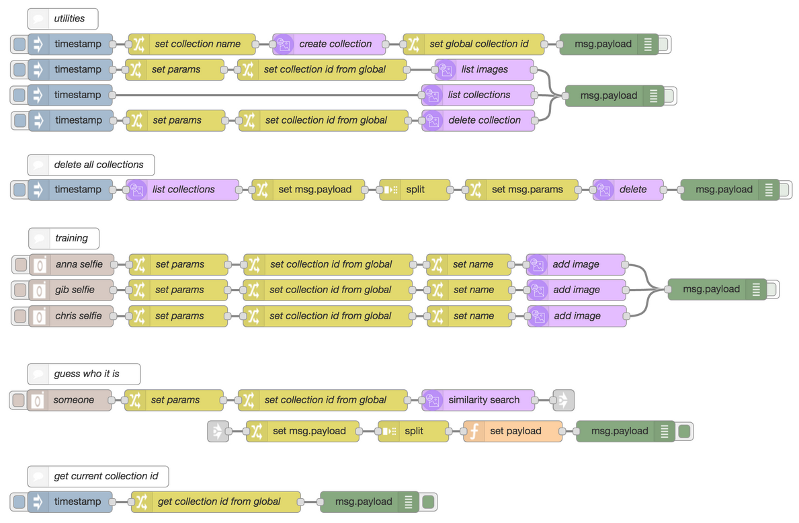

Annexes

Create your Bluemix account

IBM Bluemix is a cloud Platform as a service (PaaS) which supports several programming languages (Java, Node.js, Go, PHP, Python, Ruby...) and services as well as an integrated software development method called DevOps toolchain to build, run, deploy and manage applications easily on the cloud. Bluemix is based on Cloud Foundry open technology and runs on a SoftLayer infrastructure.
If you already have a Bluemix account, connect with your IBM ID and your Bluemix password. If not, please follow the instructions.
1. _ Connect to https://bluemix.net and click on “Create a free account”
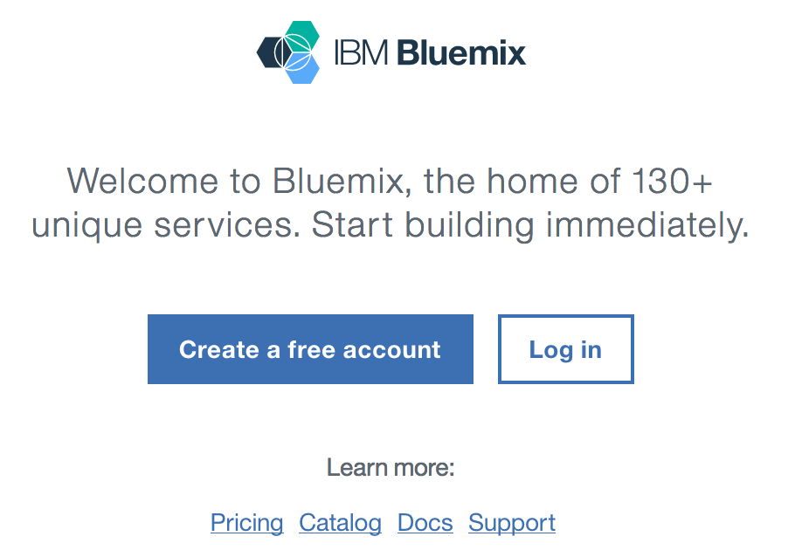

2. _ If you don’t have an IBM ID yet, please fill in the form and click on “Create account”, it will create an IBM ID and a Bluemix account. By default the Bluemix account will provide you free 30-day trial access with no credit card required. You get access to:
- 2 GB of runtime and container memory to run your applications,
- unlimited IBM services and APIs (max 10 services instances)
- and complimentary support limited to Severity 4

Create your GitHub account
Please follow the procedure : https://github.com/join

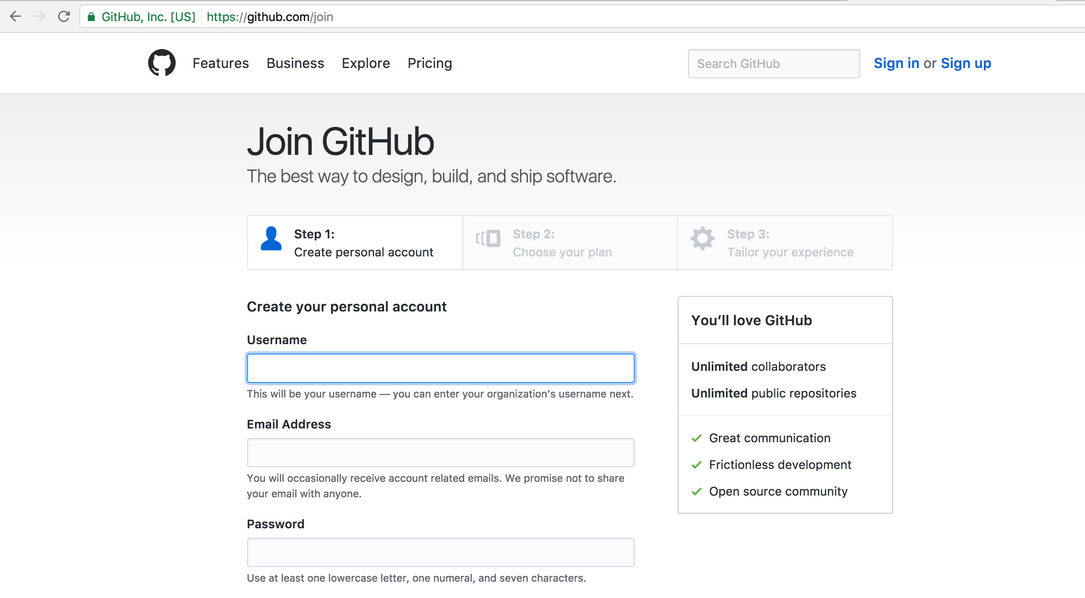
To install the Git Command Line, please follow :
https://git-scm.com/book/en/v2/Getting-Started-Installing-Git

Applying a Promo Code
If you received from the instructor a promo-code, then you have to click on the User Profile link
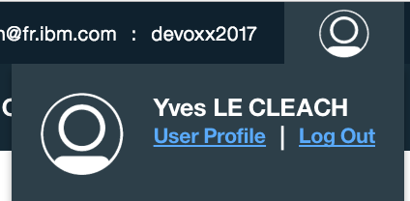

Then just enter the promo-code.

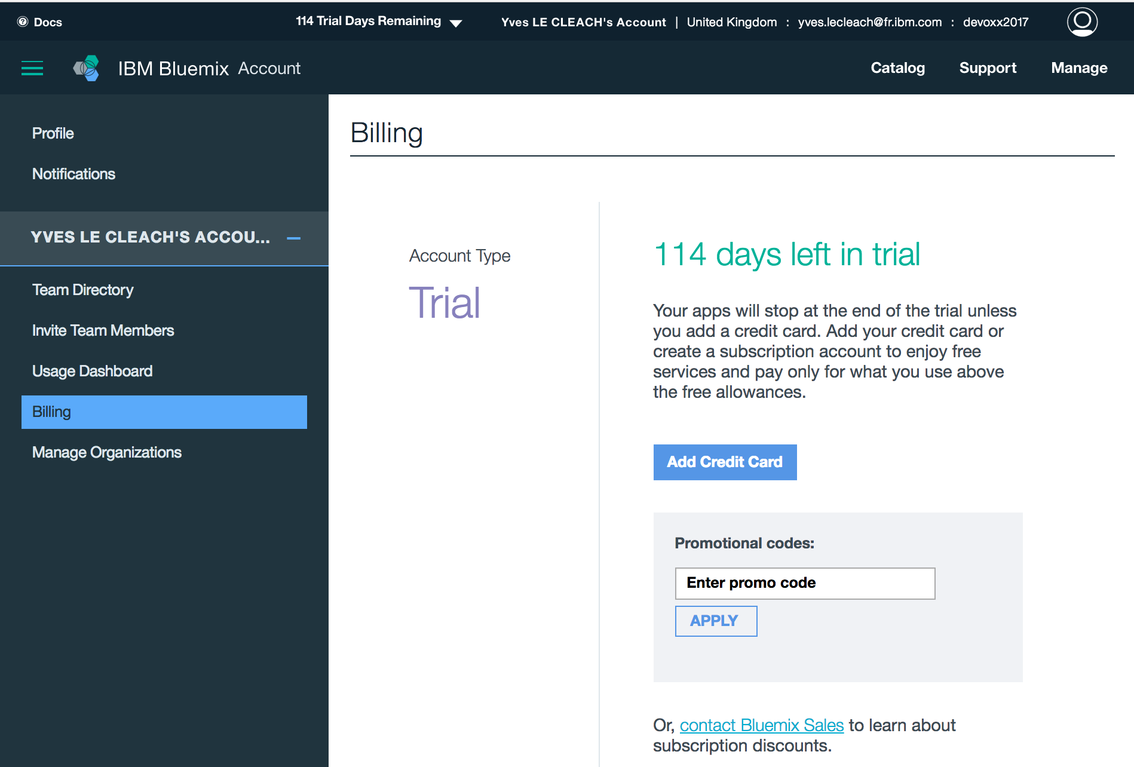

Note: each code is personal and usable once, and the account extension is variable. (e.g. could be +1 / +2 / +3 months extension of the Free Trial. (For this Devoxx France 2017 event, those promo-codes are +3 months extension of a one month trial, limited to 50 promo-codes).

Others demo

Here is another cool impressive demo to play : Dark Vision.

